Chapter 18, Problem 4.

Find the Fourier transform of the waveform shown in Fig. 18.29.

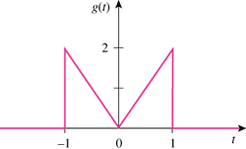

Figure 18.29
For Prob. 18.4.

